Rapport Docker Avancé
Valentin Chigot

Table des matières
VM-APP 2
Traefik 2
Keycloak 3
Wordpress 3
phpMyAdmin 4
VM-logging 5
Traefik 5
Kibana 5
Elasticsearch 6
VM-monitoring 7
Traefik 7
Uptimekuma 7

VM-APP

Traefik
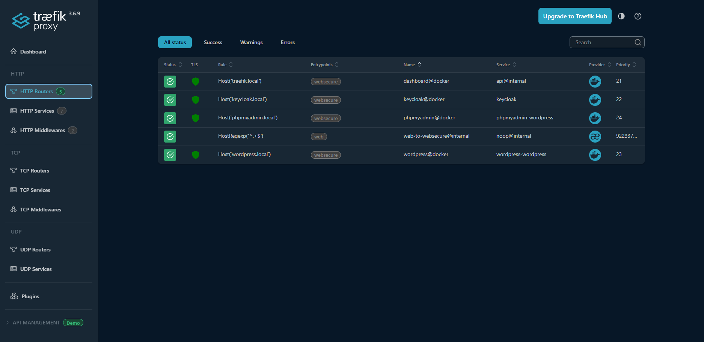
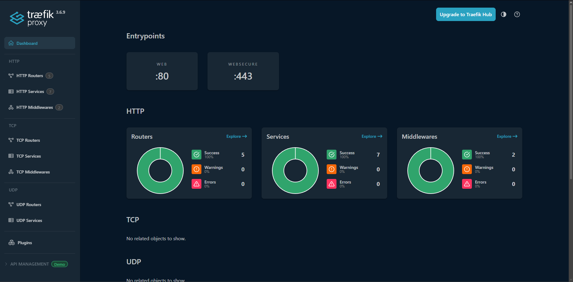

Keycloak
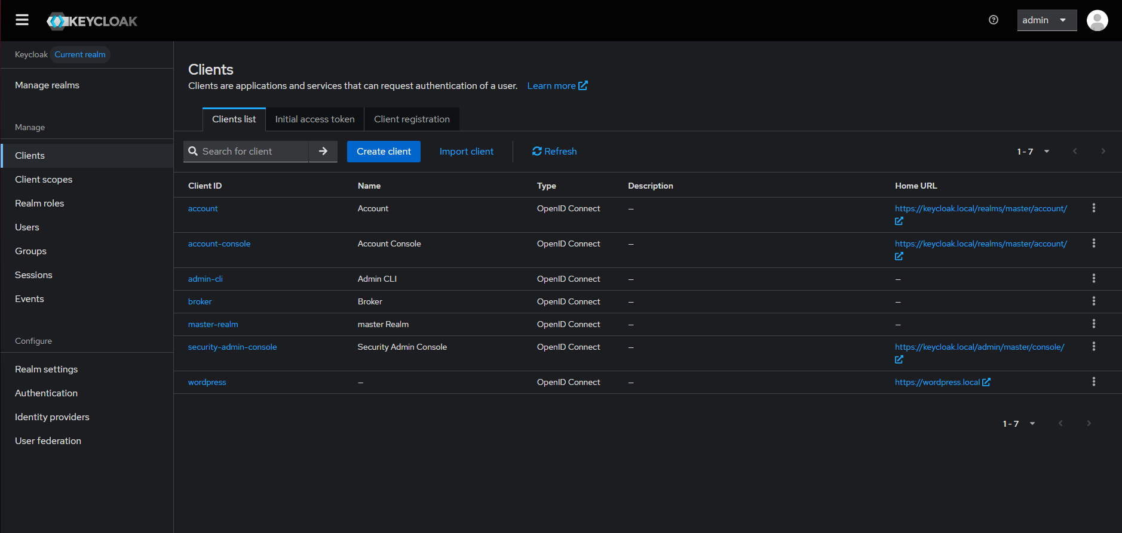

Wordpress
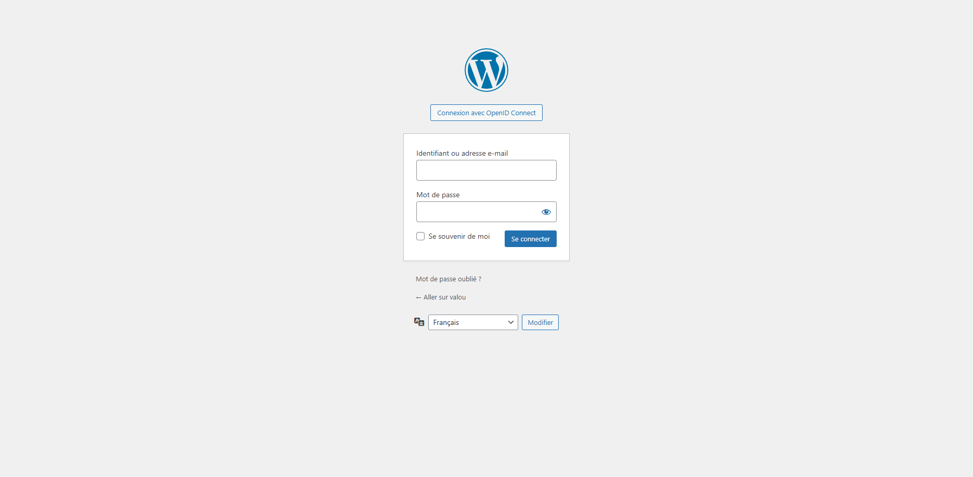
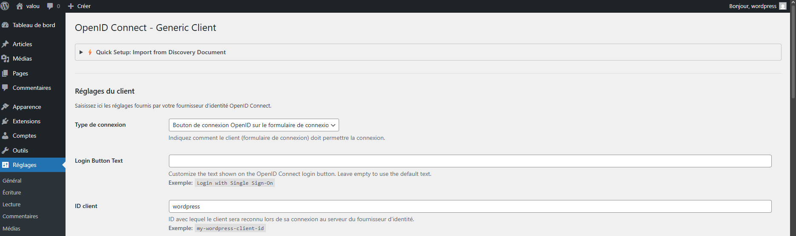

phpMyAdmin
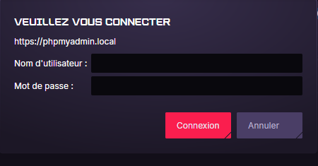
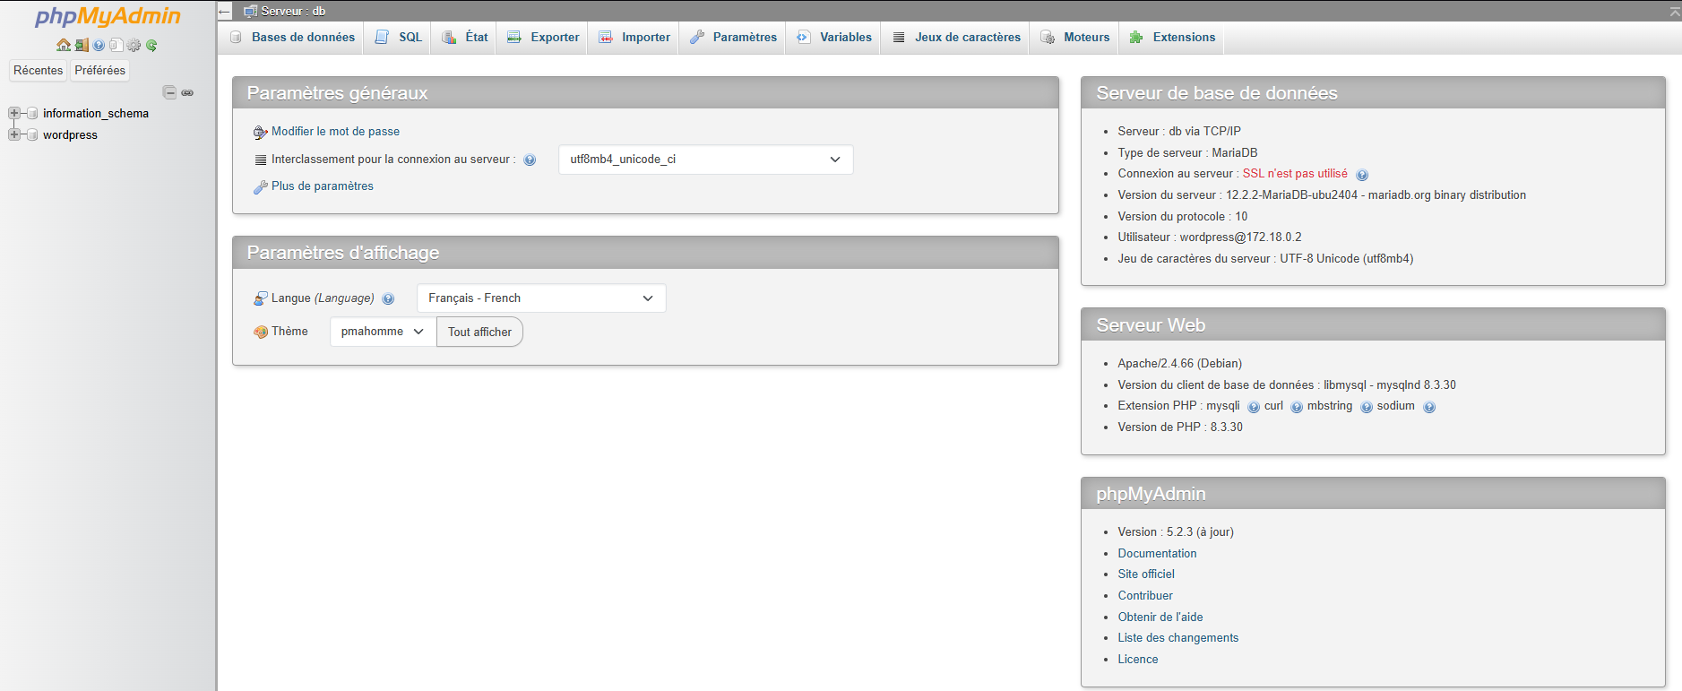

VM-logging

Traefik
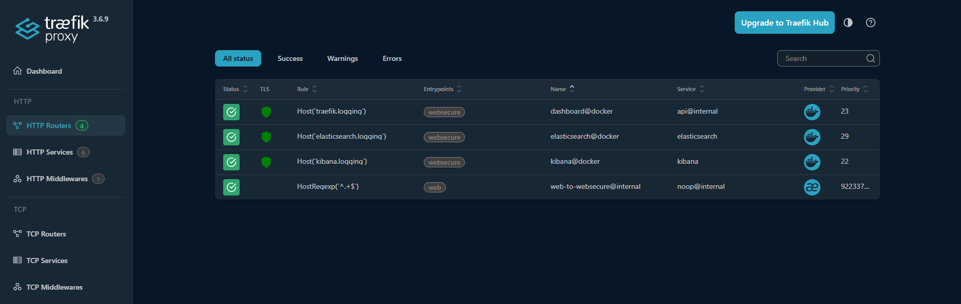

Kibana
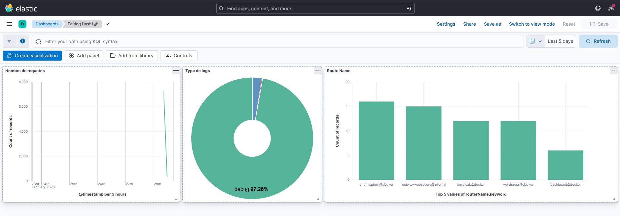
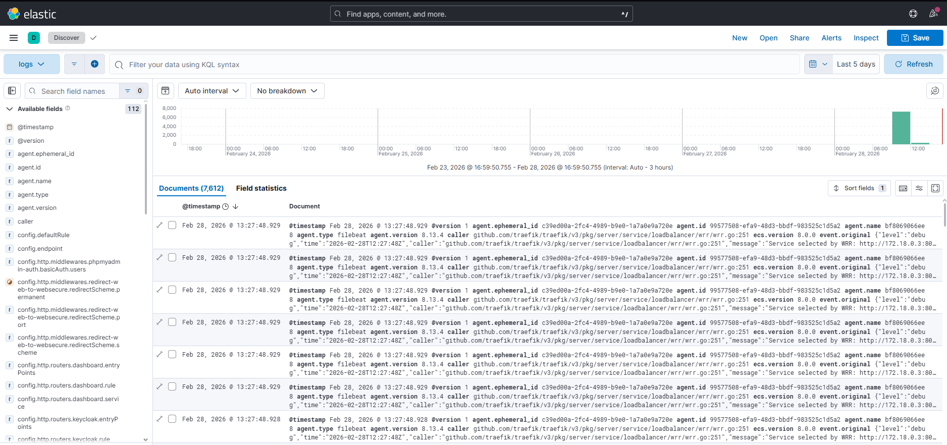

Elasticsearch
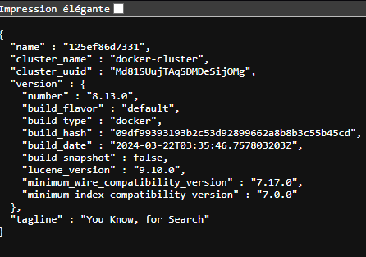

VM-monitoring

Traefik
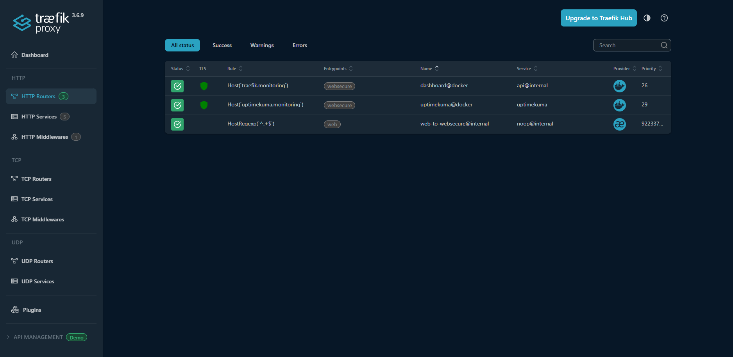

Uptimekuma
